**ETR – TIBCO Integration Document**

Table of Contents

**1.** **ETR-TIBCO integration systems** 3

**2.** **TIBCO Architecture Diagram** 5

**3.** **TIBCO APPLICATION SERVICES** 6

**3.1 Email Service:** EmailService_v1.0 (OMS🡪TIBCO🡪 WLI) 6

**3.2 Order Release Service:** OrderRelease_v1.0 (WCS🡪OMS🡪TIBCO🡪SAP) 7

**3.3 CDAX (MS Dynamics):** CDAX_v1.0 (OMS🡪TIBCO🡪MSD) 7

**3.4 AdhocRequestToMSDynamics (MS Dynamics):** AdhocRequestToMSDynamics (OMS🡪TIBCO🡪MSD) 8

**3.5 Item Status Notification Service:** ItemStatusNotification_v1.0 (SAP🡪TIBCO🡪 OMS) 9

**3.6 Return Processing Service:** ReturnsProcessing_v1.0 (OMS🡪TIBCO🡪 SAP) 10

**3.7 RMA Processing Service:** RMAProcessing_v1.0 (OMS🡨🡪 TIBCO🡨🡪 FEDEX) 11

**3.8 Inventory Sync and Inventory 3PP Service:** 12

3.8.1 Inventory Sync (InventorySync_v1.0) 12

3.8.2 Inventory Sync 3PP (InventorySync3PP_v1.0) 13

**3.9 FQM Status Update Service:** FQMStatusUpdate_v1.0 (FQM🡪TIBCO🡪OMS) 13

**3.10 Exact Target Purchase Summary:** ExactTarget_PurchaseSummary_v1.0 (OMS🡪TIBCO🡪ET) 14

**3.11 Exact Target Email Newsletter:** ExactTarget_PurchaseSummary_v1.0 (WCS🡪TIBCO 🡪[ISAC, ET]) 15

**3.12 Exact Target Cancel Order:** ExactTarget_CancelOrder_v1.0 (OMS🡪TIBCO🡪ET) 16

**3.13 Feedback Email Service:** FeedbackEmailService_v1.0 (WCS🡪TIBCO🡪CUSTOMER) 17

**3.14 Product Attribute Integration:** ProductAttributeIntgeration (SAP🡪TIBCO🡪DLP) 17

**3.15 UAM User Profile Service:** UAMUserProfileService (UAM🡪 TIBCO🡪 O365🡪MS Dynamics) 18

**3.16 SAP Adapter:** 19

**3.16.1 Order Release Adapter:** SAPOrderReleaseLB_Adapter 19

**3.16.2 Process Attribute Adapter:** SAPProductAttributes_adsap_Adapter 20

**3.16.3 Item Status Notification:** SAPSalesItemStatusNotify_adsap_Adapter 20

**3.16.4 Sales Return Adapter:** SAPSalesReturns_adsap_Adapter 21

**3.16.5 Inventory Sync Adapter:** SAPInventorySync_adsap_Adapter 21

**4. Important Contact and details:** 21

**4.1 Exact Target Email Newsletter/ Exact Target Purchase Summary:** 21

**4.2 BI Receivers Down.** 22

**4.3 TIBCO Wiki** 22

**4.4 SD ticket process for TIBCO Platform team** 22

**4.5 Receivers Count for all the services/interfaces in TIBCO and OMS.** 23

**4.6 HPI EMS Production Queue Connection details** 23

**4.7 HHO TAXWARE Down issue in PROD** 24

# **ETR-TIBCO integration systems**

In ETR, TIBCO will help integrate 2-way communications between the Sterling Order management system and other downstream applications like SAP, WLI, ISAC, MS Dynamics, UAM and Exact Target System.

**TIBCO PROD ADMINISTRATOR URL:**

Please click the below TIBCO Production Administrator link and login with the HP credential.

<https://tibco-admin-prd04-gslb1-aa-8443.glb.itcs.hpicorp.net:8443/>

Username: [xxxx@hp.com](mailto:xxxx@hp.com)

Password: HP NT Password

**TIBCO Production server details:**

|  |
| --- |
| c1t26908.itcs.hpicorp.net |
| c1t26910.itcs.hpicorp.net |
| c2t26915.itcs.hpicorp.net |
| c2t26916.itcs.hpicorp.net |

**Note: If any UNIX Patching Related to TIBCO Production Servers, then please raise an IM ticket to TIBCO Platform Team and restart all the service instances.**

**TIBCO DEV/ITG/STG environments:**

If anything related to UNIX patching for the below TIBCO servers, no action required from Application/Operation Team. No need to restart any service instances in the TIBCO Administrator console. Kindly inform to TIBCO DEV team, so that they will take care of it.

|  |  |
| --- | --- |
| **HPI TIBCO Servers** | **Environment** |
| **c4t26914.itcs.hpicorp.net** | DEV |
| **c4t26913.itcs.hpicorp.net** | DEV |
|  |  |
| **c1t28202.itcs.hpicorp.net** | ITG |
| **c4t26905.itcs.hpicorp.net** | ITG |
|  |  |
| **c1t26966.itcs.hpicorp.net** | STG |
| **c1t26967.itcs.hpicorp.net** | STG |
| **c2t26899.itcs.hpicorp.net** | STG |
| **c2t26901.itcs.hpicorp.net** | STG |

**TIBCO Build and Deployment Request for DEV/ITG/STG:**

If any build/deployment request for the TIBCO Lower environments. Kindly inform to TIBCO DEV Team and no action required from the application/Operations team.

# **TIBCO Architecture Diagram**



**Application Path for all the Services in TIBCO: Application Management > ECOM > APP_SERVICES >**

# **TIBCO APPLICATION SERVICES**

## **3.1 Email Service:** EmailService_v1.0 (OMS🡪TIBCO🡪 WLI)

It helps to send the emails (Order Creation, Fraud Decline, Shipment, Refund, VGC Shipment, and Cancellation) to customer. WLI is the end system help to trigger emails to customers.

**Application Path**: Application Management > ECOM > APP_SERVICES > EmailService_v1.0 > Service Instances

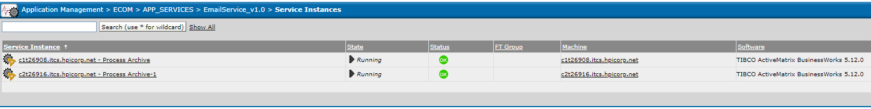

* **Queue’s Related to Email Service:**

|  |  |
| --- | --- |
| **Queue Name** | **Receiver Count** |
| HP.GLBLECOM-TRAN.EMAILSERVICE.ORDERCREATE.200536.V1.TEXT.Q | 2 |
| HP.GLBLECOM-TRAN.EMAILSERVICE.ORDERREFUND.200536.V1.TEXT.Q | 2 |
| HP.GLBLECOM-TRAN.EMAILSERVICE.ORDERSHIPMENT.200536.V1.TEXT.Q | 2 |
| HP.GLBLECOM-TRAN.EMAILSERVICE.VGCSHIPMENT.200536.V1.TEXT.Q | 2 |
| HP.GLBLECOM-TRAN.EMAILSERVICE.ORDERCANCEL.200536.V1.TEXT.Q | 2 |
| HP.GLBLECOM-TRAN.EMAILSERVICE.FRAUDDECLINE.200536.V1.TEXT.Q | 2 |

If we receive any hawk alert in the above-mentioned Service/queues. We will have to check three possible way to identify the status of the service instances.

* 1. Please check the receiver counts are available for the above-mentioned queues (Gems Tools helps to view the receivers count details).
  2. If the Receiver count is available and please check whether the receivers is consuming the messages or not.
  3. We will have to check the status of the service instances and logs in the TIBCO Administrator Console.

**Note**: (Check the logs in Admin Console) Click the Service Instances (EmailService_v1.0)🡪 Primary/Secondary Process Archive (Status-Running) 🡪 Tracing 🡪 Search for the log. Please check whether any exception has been throwing in the logs.

* If any exceptions/errors have been thrown in the logs, check with the Dev Team or raise an IM ticket to TIBCO platform Team.

## **3.2 Order Release Service:** OrderRelease_v1.0 (WCS🡪OMS🡪TIBCO🡪SAP)

Order Release service will help to transmit the order details (Order Information details) to SAP for fulfillment process.

**Application Path**:  Application Management > ECOM > APP_SERVICES > OrderRelease_v1.0 > Service Instances

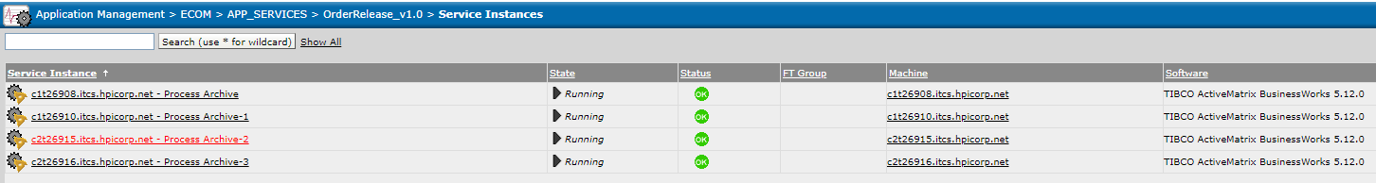

|  |  |  |
| --- | --- | --- |
| **Queue's Related to Order Release Service** | **Receiver Count** | **Details** |
| HP.GLBLECOM-TRAN.ORDERRELEASE.ORDERHANDLE.REQUEST.200536.V1.TEXT.Q | 4 | This queue is the entry point of OMS to TIBCO. It will consume the Order Release XML from OMS to TIBCO. |
| HP.GLBLECOM-TRAN.ORDERRELEASE.ORDERHANDLE.RESPONSE.200536.V1.TEXT.Q | 4 | It will send the SAP Customer ID Details from SAP to OMS |
| HP.GLBLECOM-TRAN.ORDERRELEASE.BI.ORDERHANDLE.200536.V1.TEXT.Q | 1 | It will send the Order Release XML to BI System. |

If we receive any hawk alert in the above-mentioned services/queues. We will have to check three possible way to identify the status of the service instances.

1. Please check the receiver counts are available for the above-mentioned queues (Gems Tools helps to view the receivers count details).
2. If the Receiver count is available and please check whether the receivers is consuming the messages or not.
3. We will have to check the status of the service instances and logs in the TIBCO Administrator Console.

**Note:** (Check the logs in Admin Console) Click the Service Instances (OrderRelease_v1.0)🡪(Status-Running) 🡪Tracing 🡪 Search for the log. Please check whether any exception has been throwing in the logs.

* If any exceptions/errors have been thrown in the logs, check with the Dev Team or raise an IM ticket to TIBCO platform Team.

## **3.3 CDAX (MS Dynamics):** CDAX_v1.0 (OMS🡪TIBCO🡪MSD)

CDAX service will help to send all the ETR orders to MS Dynamics System via TIBCO. Once the Order has been created in MS Dynamics then Call Center agent will able to create a Case in MS Dynamics and track the Orders till it get cancellation in SVP/ETR.

**Application Path:**  Application Management > ECOM > APP_SERVICES > CDAX_v1.0 > Service Instances

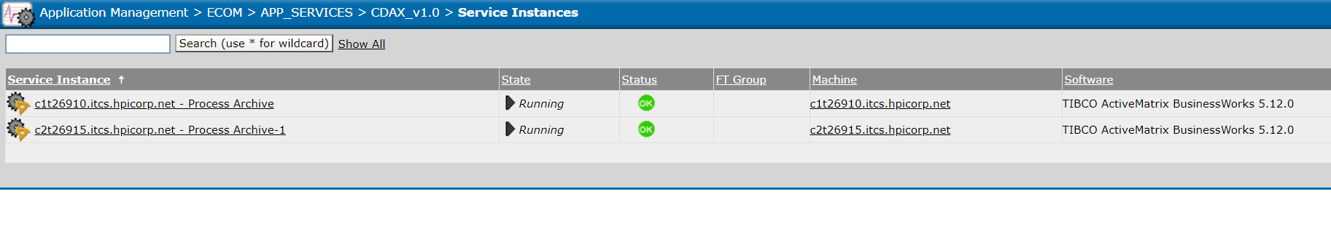

|  |  |  |
| --- | --- | --- |
| **Queue's Related to CDAX Service** | **Receiver Count** | **Details** |
| HP.GLBLECOM-TRAN.CDAX.200536.V1.TEXT.Q | 2 | This queue is the entry point of OMS to TIBCO. It will consume the Order Release XML from OMS to TIBCO and send the Orders details to MS Dynamics system. |

If we receive any hawk alert in the above-mentioned services/queues. We will have to check three possible way to identify the status of the service instances.

1. Please check the receiver counts are available for the above-mentioned queues (Gems Tools helps to view the receivers count details).
2. If the Receiver count is available and please check whether the receivers is consuming the messages or not.
3. We will have to check the status of the service instances and logs in the TIBCO Administrator Console.

**Note:** (Check the logs in Admin Console) Click the Service Instances (CDAX_v1.0)🡪(Status-Running) 🡪Tracing 🡪 Search for the log. Please check whether any exception has been throwing in the logs.

* If any exceptions/errors have been thrown in the logs, check with the Dev Team or raise an IM ticket to TIBCO platform Team.

## **3.4 AdhocRequestToMSDynamics (MS Dynamics):** AdhocRequestToMSDynamics (OMS🡪TIBCO🡪MSD)

In Sterling Call Center, there is a link (Create Case in MS Dynamics) for every order. If the Call center agent click the link then the order details will be drops to TIBCO and TIBCO will insert the order details in MS Dynamics Portal. So, Call Center agent will able to create an Case and track the order until it changed to Cancel Status in SAP/ETR.

**Application Path:**  Application Management > ECOM > APP_SERVICES > AdhocRequestToMSDynamics > Service Instances

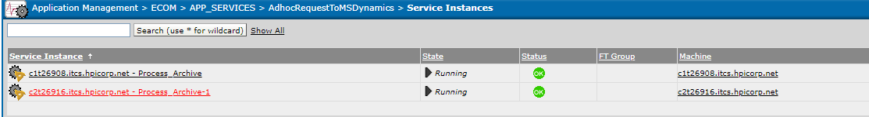

|  |  |  |
| --- | --- | --- |
| **Queue's Related to AdhocRequestToMSDynamics Service** | **Receiver Count** | **Details** |
| HP.GLBLECOM-TRAN.SFDC.200536.V1.TEXT.Q | 2 | This queue is the entry point of OMS to TIBCO. It will consume the Order Release XML from OMS to TIBCO and send the Orders details to MS Dynamics system. |

If we receive any hawk alert in the above-mentioned services/queues. We will have to check three possible way to identify the status of the service instances.

1. Please check the receiver counts are available for the above-mentioned queues (Gems Tools helps to view the receivers count details).
2. If the Receiver count is available and please check whether the receivers is consuming the messages or not.
3. We will have to check the status of the service instances and logs in the TIBCO Administrator Console.

## **3.5 Item Status Notification Service:** ItemStatusNotification_v1.0 (SAP🡪TIBCO🡪 OMS)

Item status notification service will help to send the Shipment/Cancellation/Confirmation Notification from SAP🡪TIBCO🡪 OMS System.

**Application Path**: Application Management > ECOM > APP_SERVICES > ItemStatusNotification_v1.0 > **Service Instances**

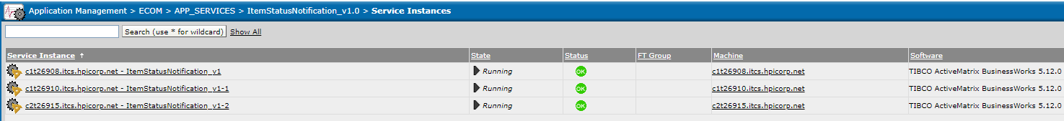

|  |  |  |
| --- | --- | --- |
| **Queue's Related to Item Status Notification Service** | **Receiver Count** | **Details** |
| HP.GLBLECOM-TRAN.ITEMSTATUSNOTIFICATION.**ORDERCONFIRM**.200536.V1.XML.Q | 4 | It will help to send the order confirmation from SAP to OMS System |
| HP.GLBLECOM-TRAN.ITEMSTATUSNOTIFICATION.**SHIPMENTNOTIFY**.200536.V1.XML.Q | 8 | It will help to send the Shipment Notification from SAP to OMS System |
| HP.GLBLECOM-TRAN.ITEMSTATUSNOTIFICATION.**ORDERCANCEL**.200536.V1.XML.Q | 4 | It will help to send the order Cancellation Notification from SAP to OMS System |

If we receive any hawk alert in the above-mentioned services/queues. All the queue related to OMS System, please check any Agent server was down in OMS end.

We will have to check three possible way to identify the status of the service instances in TIBCO.

1. Please check the receiver counts are available for the above-mentioned queues (Gems Tools helps to view the receivers count details).
2. If the Receiver count is available and please check whether the receivers is consuming the messages or not.
3. We will have to check the status of the service instances and logs in the TIBCO Administrator Console.

## **3.6 Return Processing Service:** ReturnsProcessing_v1.0 (OMS🡪TIBCO🡪 SAP)

Return Processing Service will help to send the Invoice details of Return Order and Misc. Credit Order (R and M Order) from OMS to SAP system.

**Application Path**: Application Management > ECOM > APP_SERVICES > ReturnsProcessing_v1.0 > Service Instances

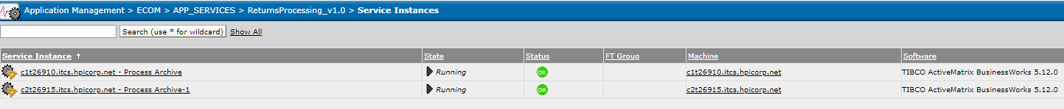

|  |  |  |
| --- | --- | --- |
| **Queue's Related to Return Processing Service** | **Receiver Count** | **Details** |
| HP.GLBLECOM-TRAN.RETURNSPROCESSING.HANDLERETURNS.REQUEST.200536.V1.XML.Q | 2 | It will send the R and M order invoice details to SAP from OMS. |
| HP.GLBLECOM-TRAN.RETURNSPROCESSING.BI.HANDLERETURNS.REQUEST.200536.V1.XML.Q | 1 | It will send the R and M order invoice details to BI System. |

If we receive any hawk alert in the above-mentioned services/queues. We will have to check three possible way to identify the status of the service instances.

1. Please check the receiver counts are available for the above-mentioned queues (Gems Tools helps to view the receivers count details).
2. If the Receiver count is available and please check whether the receivers is consuming the messages or not.
3. We will have to check the status of the service instances and logs in the TIBCO Administrator Console.

**Note:** (Check the logs in Admin Console) Click the Service Instances (ReturnsProcessing_v1.0)🡪(Status-Running) 🡪Tracing 🡪 Search for the log. Please check whether any exception has been throwing in the logs.

* If any exceptions/errors have been thrown in the logs, check with the Dev Team or raise an IM ticket to TIBCO platform Team.

## **3.7 RMA Processing Service:** RMAProcessing_v1.0 (OMS🡨🡪 TIBCO🡨🡪 FEDEX)

This service will help to receive the RMA Pick up (whether the return order has been pickup or not) response from FedEx system. OMS will send the list of return orders (Return orders in Created Status) to TIBCO for every 20 mins. TIBCO will make a web service call to FedEx System and check the response for every return orders. If the return order was pickup/Delivered in FedEx, TIBCO will send the successful response back to OMS.

**Application Path:** Application Management > ECOM > APP_SERVICES > RMAProcessing_v1.0 > Service Instances

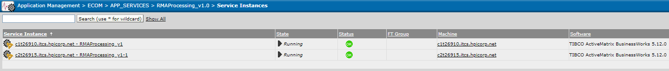

|  |  |  |
| --- | --- | --- |
| **Queue's Related to RMA Processing Service** | **Receiver Count** | **Details** |
| HP.GLBLECOM-TRAN.RMAPROCESSING.REQUEST.200536.V1.XML.Q | 2 | This queue will receive the list of Return orders from OMS system. |
| HP.GLBLECOM-TRAN.RMAPROCESSING.RESPONSE.200536.V1.XML.Q | 8 | TIBCO will send the successful response for each and every return to OMS |
| HP.GLBLECOM-TRAN.TIBCO.HANDLEFAILURE.200536.V1.TEXT.Q | 4 | TIBCO will send the failure response to OMS, if there is any issue with the Return Order. |

If we receive any hawk alert in the above-mentioned services/queues. We will have to check three possible way to identify the status of the service instances.

1. Please check the receiver counts are available for the above-mentioned queues (Gems Tools helps to view the receivers count details).
2. If the Receiver count is available and please check whether the receivers is consuming the messages or not.
3. We will have to check the status of the service instances and logs in the TIBCO Administrator Console.

**Note:** (Check the logs in Admin Console) Click the Service Instances (OrderRelease_v1.0)🡪(Status-Running) 🡪Tracing 🡪 Search for the log. Please check whether any exception has been throwing in the logs.

* If any exceptions/errors have been thrown in the logs, check with the Dev Team or raise an IM ticket to TIBCO platform Team.

## **3.8 Inventory Sync and Inventory 3PP Service:**

Inventory Service will help to receive the Full Feed/Intraday Feed from the source system and will send to OMS system for maintaining the inventory for each and every product.

**For 3PP Product**- Source System was **Ingram**. (INGRAM🡪TIBCO🡪OMS)

Ingram Server location: mercury.ingrammicro.com (TIBCO will keep on check the Full Feed/ Intraday Feed file in Ingram Server location for every 15 mins. If the files are available, TIBCO will process it and send the inventory count to OMS.)

**For STO Products**- Source System was **SAP System**. (SAP🡪TIBCO🡪OMS)

### 3.8.1 Inventory Sync (InventorySync_v1.0)

**Application Path:** Application Management > ECOM > APP_SERVICES > InventorySync_v1.0 > **Service Instances**

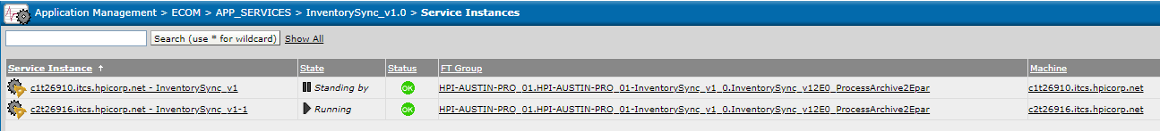

|  |  |  |
| --- | --- | --- |
| **Queue's Related to Inventory Sync Service** | **Receiver Count** | **Details** |
| HP.GLBLECOM-TRAN.INVENTORYSYNCSTO.INTRADAYFEED.RESPONSE.200536.V1.TEXT.Q | 4 | TIBCO will send the STO Intraday Inventory file to OMS. |

If we receive any hawk alert in the above-mentioned queue. This queue related to OMS System, please check any Agent server was down in OMS end.

### 3.8.2 Inventory Sync 3PP (InventorySync3PP_v1.0)

**Application Path:** Application Management > ECOM > APP_SERVICES > InventorySync3PP_v1.0 > Service Instances

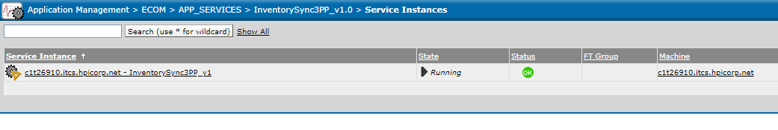

|  |  |  |
| --- | --- | --- |
| **Queue's Related to Inventory Sync 3PP Service** | **Receiver Count** | **Details** |
| HP.GLBLECOM-TRAN.INVENTORYSYNC3PP.INVENTORYFEED.RESPONSE.200536.V1.TEXT.Q | 4 | TIBCO will send the 3PP file Inventory file to OMS. |

If we receive any hawk alert in the above-mentioned queue. This queue related to OMS System, please check any Agent server was down in OMS end.

## **3.9 FQM Status Update Service:** FQMStatusUpdate_v1.0 (FQM🡪TIBCO🡪OMS)

This service will make a web service call to FQM system for every 5 minutes and send the Approved/ Declined order status to OMS/BI system.

**Application Path:** Application Management > ECOM > APP_SERVICES > FQMStatusUpdate_v1.0 > Service Instances

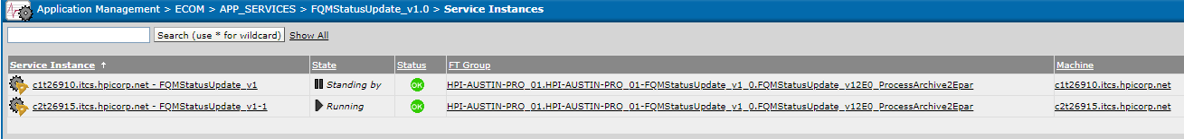

|  |  |  |
| --- | --- | --- |
| **Queue's Related to FQM Status Update Service** | **Receiver Count** | **Details** |
| HP.GLBLECOM-TRAN.FQMSTATUS.RESPONSE.200536.V1.TEXT.Q | 4 | This queue helps to send the FQM response for each and every order to OMS System. |
| HP.GLBLECOM-TRAN.FQMSTATUS.BI.RESPONSE.200536.V1.TEXT.Q | 1 | This queue helps to send the FQM response for each and every order to BI System. |

If we receive any hawk alert in the above-mentioned services/queue. This queue related to OMS/BI System, please check any Agent server was down in OMS end.

**Note : Only 1 FQM service instance should be running.. Multiple FQM service instances should not be in running state**

## **3.10 Exact Target Purchase Summary:** ExactTarget_PurchaseSummary_v1.0 (OMS🡪TIBCO🡪ET)

The Exact Target Purchase Summary will help to send the Order details and promotion details to ET System through web service.

**Application Path:**  Application Management > ECOM > APP_SERVICES > ExactTarget_PurchaseSummary_v1.0 > Service Instances

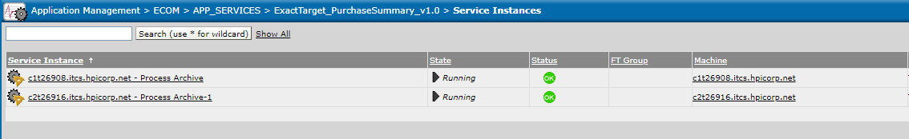

|  |  |  |
| --- | --- | --- |
| **Queue's Related to Exact Target Purchase Summary Service** | **Receiver Count** | **Details** |
| HP.GLBLECOM-TRAN.EXACTTARGET.PURCHASESUMMARY.200536.V1.XML.Q | 2 | This queue will send the order details and promotion details to ET system. |

If we receive any hawk alert in the above-mentioned services/queues. We will have to check three possible way to identify the status of the service instances.

1. Please check the receiver counts are available for the above-mentioned queues (Gems Tools helps to view the receivers count details).
2. If the Receiver count is available and please check whether the receivers is consuming the messages or not.
3. We will have to check the status of the service instances and logs in the TIBCO Administrator Console.

**Note:** (Check the logs in Admin Console) Click the Service Instances (OrderRelease_v1.0)🡪(Status-Running) 🡪Tracing 🡪 Search for the log. Please check whether any exception has been throwing in the logs.

* If any exceptions/errors have been thrown in the logs, check with the Dev Team or **raise an IM ticket to TIBCO platform Team**

## **3.11 Exact Target Email Newsletter:** ExactTarget_PurchaseSummary_v1.0 (WCS🡪TIBCO 🡪[ISAC, ET])

ET Email Newsletter service will help to send the customer profile details and Email Newsletter to different System using the SOAP Web service call.

In this ET Email Newsletter Service, we are invoking the two External systems,

1. **ISAC System**- When the customer has been created/updated their personal details in store.hp.com then the request will be sent to ISAC.
2. **Exact Target**- When the customer subscribed the Email Newsletter in Store/Call Center then the request will be sent to ET System.

**Application Path:**  Application Management > ECOM > APP_SERVICES > ExactTarget_EmailNewsLetter_v1.0 > Service Instances

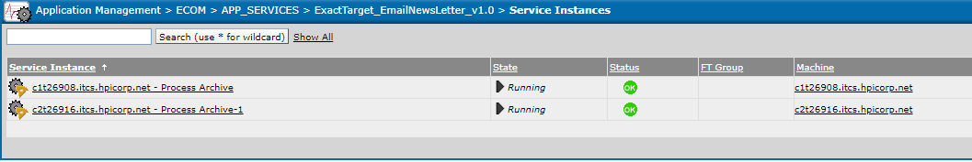

|  |  |  |
| --- | --- | --- |
| **Queue's Related to Exact Target Email Newsletter Service** | **Receiver Count** | **Details** |
| HP.GLBLECOM-TRAN.EXACTTARGET.EMAILNEWSLETTER.200536.V1.XML.Q | 2 | WCS will send the message to this queue and the required message will be to send to ET and ISAC System through web service call. |

If we receive any hawk alert in the above-mentioned services/queue. We will have to check three possible way to identify the status of the service instances.

1. Please check the receiver counts are available for the above-mentioned queues (Gems Tools helps to view the receivers count details).
2. If the Receiver count is available and please check whether the receivers is consuming the messages or not.
3. We will have to check the status of the service instances and logs in the TIBCO Administrator Console.

**Note:** (Check the logs in Admin Console) Click the Service Instances (ExactTarget_PurchaseSummary_v1.0)🡪(Status-Running) 🡪Tracing 🡪 Search for the log. Please check whether any exception has been throwing in the logs.

* If any exceptions/errors have been thrown in the logs, check with the Dev Team or **raise an IM ticket to TIBCO platform Team**

## **3.12 Exact Target Cancel Order:** ExactTarget_CancelOrder_v1.0 (OMS🡪TIBCO🡪ET)

The Exact Target cancel Order will help to send the cancel Order details to ET System through web service.

**Application Path:**  Application Management > ECOM > APP_SERVICES > ExactTarget_CancelOrder_v1.0 > Service Instances

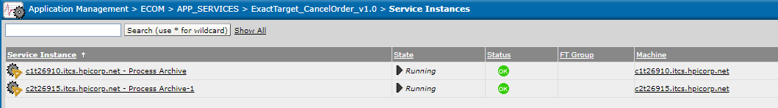

|  |  |  |
| --- | --- | --- |
| **Queue's Related to Exact Target Cancel Order Service** | **Receiver Count** | **Details** |
| HP.GLBLECOM-TRAN.EXACTTARGET.CANCELORDERNOTIFICATIONTOET.200536.V1.XML.Q | 2 | This queue will send the Cancel order details to ET system. |

If we receive any hawk alert in the above-mentioned services/queues. We will have to check three possible way to identify the status of the service instances.

1. Please check the receiver counts are available for the above-mentioned queues (Gems Tools helps to view the receivers count details).
2. If the Receiver count is available and please check whether the receivers is consuming the messages or not.
3. We will have to check the status of the service instances and logs in the TIBCO Administrator Console.

**Note:** (Check the logs in Admin Console) Click the Service Instances (ExactTarget_CancelOrder_v1.0)🡪(Status-Running) 🡪Tracing 🡪 Search for the log. Please check whether any exception has been throwing in the logs.

* If any exceptions/errors have been thrown in the logs, check with the Dev Team or raise an IM ticket to TIBCO platform Team.

## **3.13 Feedback Email Service:** FeedbackEmailService_v1.0 (WCS🡪TIBCO🡪CUSTOMER)

In Our Store, there is an option for Send Us Email functionality, if the customer requested some information so that we will send the email to customer/HP Team for any enquiry about product. Feedback Email Service will help to send the email via TIBCO.

**Application Path:** Application Management > ECOM > APP_SERVICES > FeedbackEmailService_v1.0 > Service Instances

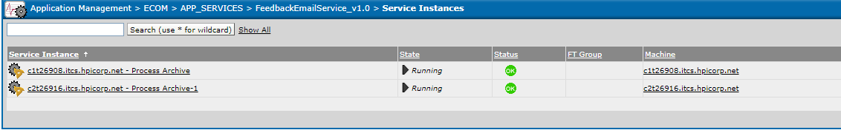

|  |  |  |
| --- | --- | --- |
| **Queue's Related to Feedback Email Service** | **Receiver Count** | **Details** |
| HP.GLBLECOM-TRAN.FEEDBACKEMAILSERVICE.HANDLEEMAIL.200536.V1.TEXT.Q | 2 | WCS will send the message to this queue and the TIBCO will use the data and trigger an email to customer. |

## **3.14 Product Attribute Integration:** ProductAttributeIntgeration (SAP🡪TIBCO🡪DLP)

Product attribute flow will help to receive the product related information (Product Id, Weight, Size, etc.) from SAP and inserting the information to DLP database via TIBCO. This activity will be carried out once per day in TIBCO with the consolidated details.

**Application Path:** Application Management > ECOM > APP_SERVICES > ProductAttributeIntgeration > Service Instances

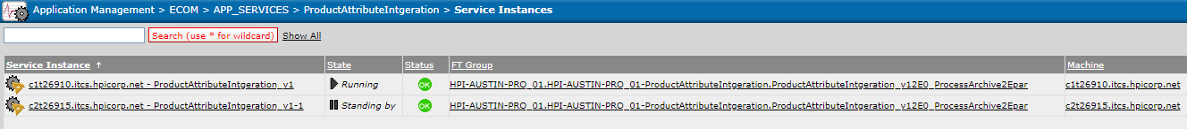

It will always communicate with the Adapter Service instance (SAPProductAttributes_adsap_Adapter) to receive the product information from SAP.

|  |  |  |
| --- | --- | --- |
| **Queue's Related to Feedback Email Service** | **Receiver Count** | **Details** |
| HP.GLBLECOM-TRAN.ADAPTER.PRODUCTATTRIBUTES.SUBSCRIBE.200536.V1.XML.Q | 1 | Receive the product related information from SAP |

If we receive any hawk alert in the above-mentioned services/queue. We will have to check three possible way to identify the status of the service instances.

1. Please check the receiver counts are available for the above-mentioned queues (Gems Tools helps to view the receivers count details).
2. If the Receiver count is available and please check whether the receivers is consuming the messages or not.
3. We will have to check the status of the service instances and logs in the TIBCO Administrator Console.

**Note:** (Check the logs in Admin Console) Click the Service Instances (ProductAttributeIntgeration) 🡪(Status-Running) 🡪Tracing 🡪 Search for the log. Please check whether any exception has been throwing in the logs.

* If any exceptions/errors have been thrown in the logs, check with the Dev Team or raise an IM ticket to TIBCO platform Team.
* **Make sure this service will be running in c1t26910.itcs.hpicorp.net server constantly. It should not be splitted to another server as tibco will be taking an consolidated file on daily basis and send to DLP**

## **3.15 UAM User Profile Service:** [UAMUserProfileService](https://c1t11122.itcs.hpicorp.net:8443/administrator/servlet/tibco_administrator?c.fid=com_tibco_wfc_DefaultFrame_2103160838&fdc=31) (UAM🡪 TIBCO🡪 O365🡪MS Dynamics)

If the Call Center agent profiles creation/removal in MS Dynamics will be initiated in the UAM console.

**User Profile Creation:**

Whenever business will submit a request for new profile creation for the call center agent and those requests will be consumed by TIBCO and assign the MS Dynamics license for the agents (in Office 365), then the user details with roles and responsibility will be enable in MS Dynamics.

**User Profile Removal:**

Any users/agents are not part of HPI, business will request for a removal access in UAM and then the MS Dynamics license and profile details will be removed in MS Dynamics.

|  |  |  |
| --- | --- | --- |
| **Queue's Related to UAMUserProfileService** | **Receiver Count** | **Details** |
| HP.GLBLECOM-CRM.UAM.ADDPROFILE.200536.V1.TEXT.Q | 1 | This queue will consume the user profile creation data from UAM and helps to create the users in MS Dynamics |
| HP.GLBLECOM-CRM.UAM.REMOVEPROFILE.200536.V1.TEXT.Q | 1 | This queue will consume the user profile removal data from UAM and helps to remove the users profile details in MS Dynamics. |

## **3.16 SAP Adapter:**

SAP adapter it helps to communicate with SAP and TIBCO System.

1. TIBCO will transform the input XML and converted into IDOC format. IDOC was the format that is understood by SAP System.
2. SAP will send the IDOC and TIBCO will convert it to XML format.

|  |  |
| --- | --- |
| **ADAPTERS --> Connectivity with SAP System** |  |
| **Queue Names** | **Receiver Count** |
| HP.GLBLECOM-TRAN.ADAPTER.INVENTORYSYNC.SUBSCRIBE.200536.V1.XML.Q | 1 |
| HP.GLBLECOM-TRAN.ADAPTER.ITEMSTATUSNOTIFICATION.SUBSCRIBE.200536.V1.XML.Q | 3 |
| HP.GLBLECOM-TRAN.ADAPTER.ORDERRELEASE.REQ.RES.200536.V1.XML.Q | 4 |
| HP.GLBLECOM-TRAN.ADAPTER.PRODUCTATTRIBUTES.SUBSCRIBE.200536.V1.XML.Q | 1 |
| HP.GLBLECOM-TRAN.ADAPTER.RETURNSPROCESSING.REQ.RES.200536.V1.XML.Q | 2 |

If we receive any hawk alert in the above-mentioned queue. We will have to check three possible way to identify the status of the adapters.

1. Please check the receiver counts are available for the above-mentioned queues (Gems Tools helps to shows the receivers count details).
2. If the Receiver count is available and please check whether the receivers is consuming the messages or not.
3. We will have to check the status of the service instances in the TIBCO Administrator Console.

### **3.16.1 Order Release Adapter:** SAPOrderReleaseLB_Adapter

This adapter will help to send the orders to SAP for fulfillment process.

**Application Path:** Application Management > ECOM > AdapterServices > SAPOrderReleaseLB_Adapter > **Service Instances**

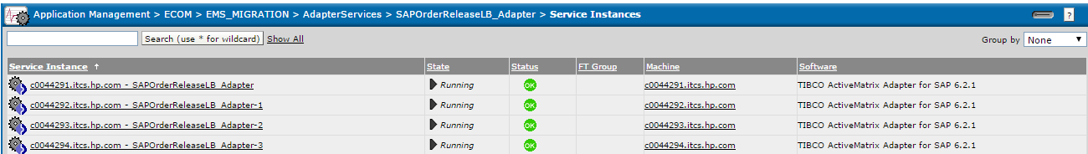

**Note:** Please click each and every Service Instances (SAPOrderReleaseLB_Adapter) 🡪 Tracing 🡪 Search for the log. If any exception occurs in the logs, check with Dev team or raise an IM ticket to restart the SAPOrderReleaseLB_Adapter.

**Order Release Adapter Queue:** HP.GLBLECOM-TRAN.ADAPTER.ORDERRELEASE.REQ.RES.200536.V1.XML.Q

### **3.16.2 Process Attribute Adapter:** SAPProductAttributes_adsap_Adapter

This Adapter will help to receive the Product Attribute from SAP System.

**Application Path:** Application Management > ECOM > AdapterServices > SAPProductAttributes_adsap_Adapter > **Service Instances**

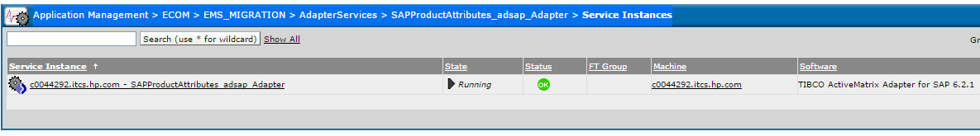

**Note:** Please click each and every Service Instances (SAPProductAttributes_adsap_Adapter) 🡪 Tracing 🡪 Search for the log. If any exception occurs in the logs, check with Dev team or raise an IM ticket to restart the SAPProductAttributes_adsap_Adapter.

**Process Attribute Adapter Queue:** HP.GLBLECOM-TRAN.ADAPTER.PRODUCTATTRIBUTES.SUBSCRIBE.200536.V1.XML.Q

### **3.16.3 Item Status Notification:** SAPSalesItemStatusNotify_adsap_Adapter

ThisAdapter will help to receive the Shipment/Cancellation/Confirmation Notification from SAP to TIBCO System.

**Application Path:**  Application Management > ECOM > AdapterServices > SAPSalesItemStatusNotify_adsap_Adapter > **Service Instances**

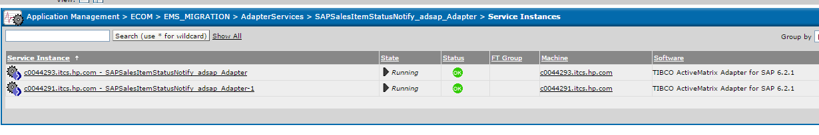

**Note:** Please click each and every Service Instances (SAPSalesItemStatusNotify_adsap_Adapter) 🡪 Tracing 🡪 Search for the log. If any exception occurs in the logs, check with Dev team or raise an IM ticket to restart the SAPSalesItemStatusNotify_adsap_Adapter.

**Item Notification Adapter Queue:** HP.GLBLECOM-TRAN.ADAPTER.ITEMSTATUSNOTIFICATION.SUBSCRIBE.200536.V1.XML.Q

### **3.16.4 Sales Return Adapter:** SAPSalesReturns_adsap_Adapter

This Adapter will help to send the Return Orders and Misc. Credit Orders (R and M orders) to SAP System.

**Application Path:** Application Management > ECOM > AdapterServices > SAPSalesReturns_adsap_Adapter > **Service Instances**

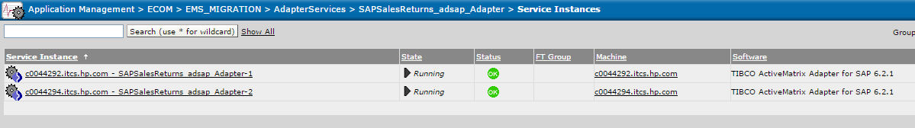

**Note:** Please click each and every Service Instances (SAPSalesReturns_adsap_Adapter) 🡪 Tracing 🡪 Search for the log. If any exception occurs in the logs, check with Dev team or raise an IM ticket to restart the SAPSalesReturns_adsap_Adapter.

**Sales Return Adapter Queue:** HP.GLBLECOM-TRAN.ADAPTER.RETURNSPROCESSING.REQ.RES.200536.V1.XML.Q

### **3.16.5 Inventory Sync Adapter:** SAPInventorySync_adsap_Adapter

This Adapter will help to receive the Inventory load (Full Feed and Delta Feed) from SAP System.

**Application Path:** Application Management > ECOM > AdapterServices > SAPInventorySync_adsap_Adapter > **Service Instances**

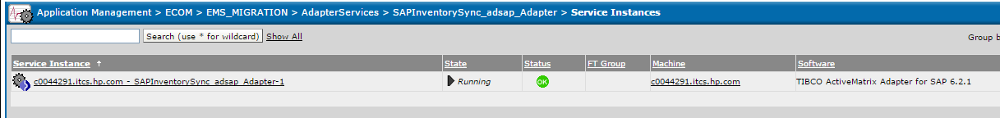

**Note:** Please click each and every Service Instances (SAPInventorySync_adsap_Adapter) 🡪 Tracing 🡪 Search for the log. If any exception occurs in the logs, check with Dev team or raise an IM ticket to restart the SAPInventorySync_adsap_Adapter.

**Inventory Sync Adapter Queue**: HP.GLBLECOM-TRAN.ADAPTER.INVENTORYSYNC.SUBSCRIBE.200536.V1.XML.Q

# **4. Important Contact and details:**

## **4.1 Exact Target Email Newsletter/ Exact Target Purchase Summary:**

If there is any issue with the Exact Target System (Newsletter/Purchase Summary) please send an email to the below contacts

Contact Details: Hayato Yoshida <Hayato.Yoshida@acxiom.com>; HPteamtech - Hewlett Packard Technical Team e-mail <HPteamtech@acxiom.com>; Goodarz, Mehraban (Customer Intelligence) <mehraban.goodarz@hp.com>; Schaefer, Kate kate.p.schaefer@hp.com

## **4.2 BI Receivers Down.**

If there is any issue with the below queue (More messages are pending in the queue) or the Receivers are down, send an email to below contacts.

|  |  |
| --- | --- |
| **BI Queue's** | **Receivers Count** |
| HP.GLBLECOM-TRAN.FQMSTATUS.BI.RESPONSE.200536.V1.TEXT.Q | 1 |
| HP.GLBLECOM-TRAN.ORDERRELEASE.BI.ORDERHANDLE.200536.V1.TEXT.Q | 1 |
| HP.GLBLECOM-TRAN.RETURNSPROCESSING.BI.HANDLERETURNS.REQUEST.200536.V1.XML.Q | 1 |

**Contact Details:** Chitrala, Shiva Kumar <shiva-kumar.c@hpe.com>; Kumar, Sujeet <sujeet.kumar2@hp.com>; DS-IC-hp.com-Analytics <GADSC-HP.COM-ANALYTICS@hp.com>; Boggula, Bhargavi <disabled-bhargavi.boggula@hp.com>; C, Sudarshan <sudarshan@hp.com>; Singh, Harvinder <harvinder.gill@hp.com>; Gauvin, Pierre (Global eCommerce & MarCom Tech) <pierre.gauvin@hp.com>; ISS L4 Inc <informaticassl4inc@hp.com>; Bm, Manjunath <manjunath.bm@hpe.com>

**More info:** **IM22783344**

## **4.3 TIBCO Wiki**

TIBCO Wiki will helps to understand the overall architecture in ETR and it contains queue configuration and server details of all TIBCO Environment.

**TIBCO WIKI:** <https://c1t11995.itcs.hpicorp.net/wiki/TIBCO_Platform_HPECOM>

## **4.4 SD ticket process for TIBCO Platform team**

Please follow the below attachment for creating the SD ticket to Platform team.



## **4.5 Receivers Count for all the services/interfaces in TIBCO and OMS.**

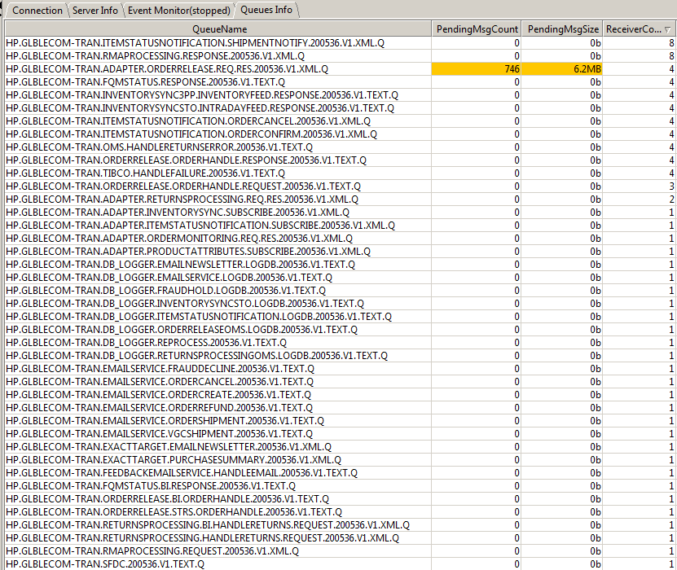

## **4.6 HPI EMS Production Queue Connection details**

|  |  |
| --- | --- |
| **PROD Environment** | **TIBCO HPI Connection Details** |
|  |  |
| JNDI URL | tibjmsnaming://tibco-ems-hpi-prd01-gslb01-aa-8000.austin.hpicorp.net:8000 |
| JNDI Username | hpiecom |
| JNDI Password | hpiecom_pass |
| Queue Connection Factory | HPI.ECOM.APP_202121.failsafe01.QCF |
| Topic Connection Factory | HPI.ECOM.APP_202121.failsafe01.TCF |
| Provided URL | tcp://g2u2360c.austin.hpicorp.net:9024,tcp://g2u2361c.austin.hpicorp.net:9024,tcp://g1u3553c.austin.hpicorp.net:9024,tcp://g1u3554c.austin.hpicorp.net:9024 |

## **4.7 HHO TAXWARE Down issue in PROD**

Once the ETR/ETR-TIBCO send the order details to SAP for creation, then SAP will intern call the HHO TAXWARE System for calculating the tax for that order. If any issue with the Tax ware, ETR-TIBCO receive the below exception. Please check with SAP and HHO Taxware for resolving the issue.

**Exception:**

WTAX_TXJCDCommunication error with the external tax system (TAXWARE),,,

EF2Jurisdiction code could not be determined,,,SALES_HEADER_IN

EV4Sales docume"

**Connection Test in SAP SVP:**

Decode – SM59 console

